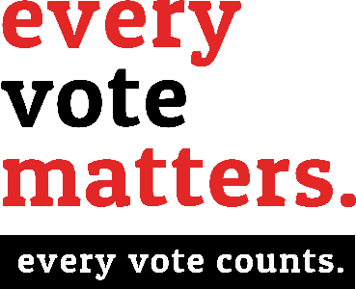 Be A Poll

W O R K E R
Call 843-549-2842 TODAY

Want to get paid to do a good thing? You can earn money as a poll worker — and the experience be rewarding!
If you qualify and are chosen to serve as an election worker, you could earn $135 just for helping out.
And you’d be serving your community —
Being a poll worker is a fun opportunity to meet new people and to participate in the election procedures. Besides, your neighbors need more people like you to work at the polls. Colleton County Voter Registration & Elections must recruit and train hundreds of poll workers every general election year.
Your county election officials can teach you everything you need to know to do the job. You just need to meet (but not limited to) a few requirements to be selected:
- You must be a U.S. citizen;
- You should be at least 16 years old
- If you are 18 or over, you must also be registered to vote in South Carolina

- I can report to the polling location by 6 a.m. on Election Day.
- I can attend a 3-hour training session.
- I can work until the polls close after 7 p.m. on Election Day.
- I can work at any polling location in Colleton County.
- I am at least 16 years old. (If 18, you must be registered to vote in S.C.)

Name:

Mailing Address:

City: State: Zip:

Email:

Daytime Phone: Date of Birth:

Voter Registration Number:

Colleton County Board of Voter Registration & Elections Board Use Only
843-549-2842

cwilliams@colletoncounty.org or voterregistration@colletoncounty.org
Angela G. Upchurch, Director
Cynthia P. Williams, Deputy Director

