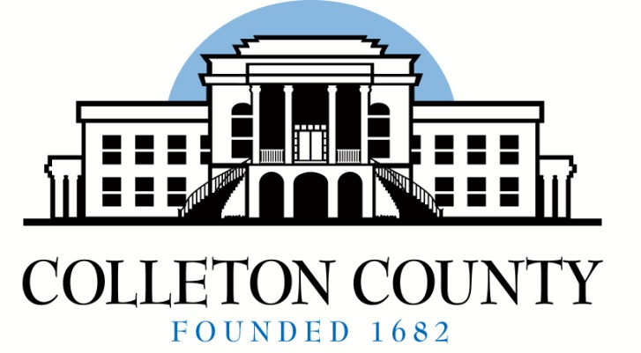

Angela G. Upchurch
Director
aupchurch@colletoncounty.org

72 Bells Hwy
P.O. Box 97
Walterboro, SC 29488
Telephone: (843) 549-2842

BOARD MEMBERS
Queenie L. Crawford
Chairperson
Celia S. Price
Kimber L. Santorella
Janis K. Blocker
Timothy D. Hamilton
Patricia A. Grant
Scott S. Lenger

Board of Voter Registration and Elections

2025 Quarterly Board Meeting Schedule

The Colleton County Board of Voter Registration and Elections holds regular meetings on the second Tuesday in the months of March, June, September and December at 5:30 p.m. Quarterly board meetings are held at this office located at 72 Bells Hwy., Walterboro, S.C.

** The time, dates and location are subject to change. Special meetings are held as needed. **

March 11, 2025

June 10, 2025

September 9, 2025

December 9, 2025

