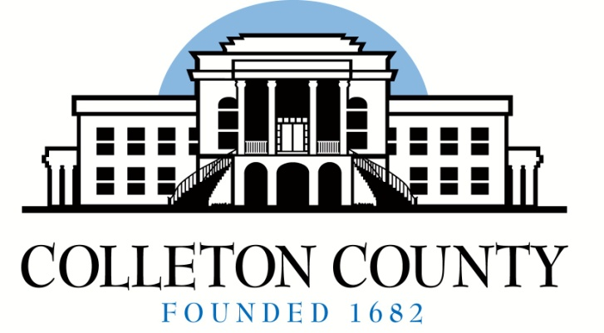

BOARD MEMBERS
Queenie L. Crawford
Chairperson
Celia S. Price
Janis K. Blocker
Timothy D. Hamilton
Patricia A. Grant
Scott S. Lenger
John F. Harper

Angela G. Upchurch
Director
aupchurch@colletoncounty.org

72 Bells Hwy
P.O. Box 97
Walterboro, SC 29488
Telephone: (843) 549-2842

Board of Voter Registration and Elections

2026 Quarterly Board Meeting Schedule

The Colleton County Board of Voter Registration and Elections holds regular meetings on the second Tuesday in the months of March, June, September and December at 5:30 p.m. at 72 Bells Hwy.
The date, time and location are subject to change.

*March 05, 2026 Immediately following Canvass & Certification of March 3, 2026 Town of Lodge Special Election

*June 11, 2026 Immediately following Canvass & Certification of June 9, 2026 Statewide Primary

September 8, 2026

December 8, 2026

